
Sreenidhi Institute of Science and Technology
Regulations:
A14
(An Autonomous Institution)
Code No: 4H112 Date:29-Dec-16 (FN)
B. TECH. I-Year I-Semester Examinations, Dec-2016/Jan-2017 (Supplementary)
MATHEMATICS FOR BIOTECHNOLOGY - I(BT)

Time: 3 Hours Max. Marks:70
Note: a) No additional answer sheets will be provided.
b) All sub-parts of a question must be answered at one place only, otherwise it will not be valued.
c) Assume any missing data.

Part - A
Max.Marks:20

Answer all QUESTIONS
1. If u= x²+y²+z² then find 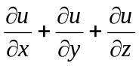 at (1, 2, 3). (2M)

2. If z = log(x² +y²) find 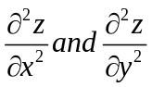 (2M)
3 . Evaluate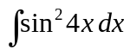 (2M)
4. Define function .Give two examples of one one and onto functions (2M)

5. Find the equation of the straight line parallel to the line 4x+5y+8=0 and passing through the
point (1,6) (2M)

6. Evaluate the value of sin15 ⁰ (2M)

7. Evaluate 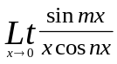 (2M)

8. Find the derivative of sin(logx) (2M)

9. Find the derivative of 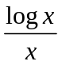 (2M)
10. Dicuss the continuity of f(x)= 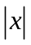 at x=0. (2M)

Part – B
Max.Marks:50
ANSWER ANY FIVE QUESTIONS. EACH QUESTION CARRIES 10 MARKS.

1(a) Evaluate 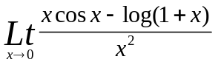
(b) Discuss the continuity of 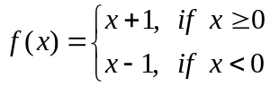 at x = 0.

2(a) If y = a sin mx + b cos mx, show that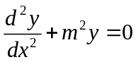
(b)Find the extreme value of 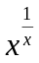

3(a) Find the square root of 3-4i
(b) Find the value of 2 tan²45⁰ +4 Sin²60⁰ +6 Cot²30⁰+8 Sec²45⁰

4(a) Find the equation of straight line passing through (2,-4) and parallel to the line 6x+8y+15=0
(b) Find the center and radius of the circle 2x²+2y²+6x+8y+5=0

5(a)Evaluate 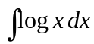
(b)Evaluate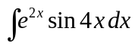

6(a) Show that 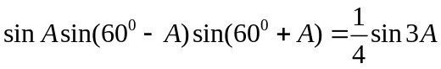
(b) Find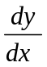 ,if x= a cos³ t, y = a sin³ t
7(a) Evaluate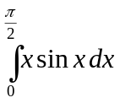
(b)Find the area between the curves y=x² and x²=y

8(a) Find the derivative of tan2x using the fist principle
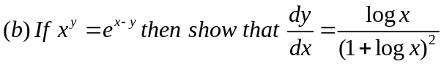

-- 00 -- 00 --

